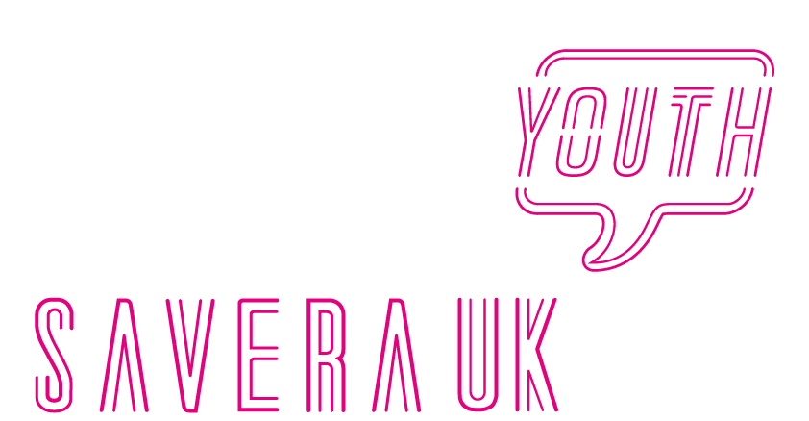
YOUTH ADVISORY BOARD APPLICATION FORM

Please fill in the application form and return it to:
By Post:
Savera UK, 151 Dale St,
Liverpool, L2 2AH
By Email:
yab@saverauk.co.uk

Full Name:
Date of Birth:
Address:
Postcode:
Phone Number:
Email Address:
Name and number of emergency contact:
College/University:
Would you like to be added to our mailing list? | YES ☐ NO ☐
Where did you hear about us?

Rehabilitation of offenders Act
Applicants are not entitled to withhold any information about conviction which for other purposes are “Spent” under the provision of the Act 1974and in the event of employment, any failure to disclose such conviction could result in dismissal or disciplinary action by the employing organisation. Any information given will be confidential and will be considered. Only relevant convictions and information will be taken into account and convictions will not necessarily bar applicants from the position.

Please note any criminal convictions, except those spent under the Rehabilitation of Offenders Act 1974. If none, please state. If yes please give details

Please describe below how your experience and skills make you suitable for a place in the Savera UK Youth Advisory Board (350 words max.)
Why do you want to join the Savera UK Youth Advisory Forum? (350 words max.)
Why do you think it is important to have an organisation like Savera UK? (200 words max.)
Please tell us a little bit about yourself… (200 words max.)

Reference
Please provide details of your reference below.
Name:

Relationship to you:

Job Title:

Company/Address:

Postcode:

Contact Number:

Email:

