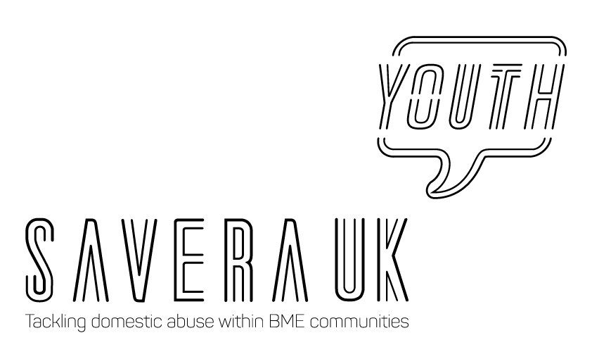
SAVERA UK YOUTH PROGRAMME: Youth Advisory Board (YAB)

Background

Savera UK a leading organisation established in 2010, its aim is tackling and campaigns to eliminate ‘honour’-based abuse and harmful practices and provide a culturally-specific and life-saving services to those at risk, regardless of age, culture, sexuality or gender.

We advocate for those who need a voice and offer a completely confidential and non-judgemental service.

Savera UK Youth is a group of young people aged 11 – 25 years who are passionate about speaking out and raising awareness amongst their peers about ‘honour’-based abuse (HBA) and harmful practices and campaigning towards ending these practices.

Savera UK will address the gap and raise awareness about HBA and harmful practices within communities, cultural diversity and the rights of a child. These issues are still not addressed in schools or are part of the UK school curricula, so it is vital to educate future generations about HBA and harmful practices to prevent them, as well as making them aware of these issues amongst their peer groups.

The Savera UK Youth projects will empower and encourage young people and inspire them to lead and advocate for the work that Savera UK does, allowing them to develop and gain skills and opportunities.

What is the Youth Advisory Board?

The YAB is a group of young people who come together to make a positive change for young people and the communities they live in. The YAB aims to identify issues that impact on young people and to play a strategic role in meeting these needs. YAB are the voice of young people at Savera UK, providing a youth perspective on the organisation’s activities. YABs identify the issues that young people care most about and then take action through campaigning, lobbying, advocacy and advising about commissioning services. The YAB's ambition is to influence services design, delivery and policies, to make them what young people want and need, and to improve outcomes for all young people and their futures. YABs are young people’s opportunity to have a say in the decisions affecting young people in the area.

Who can be part of the Youth Advisory Board?

Savera UK is open to applications for YAB (see YAB Application Form). The age limit is currently 11-25. The YAB will have a total of ten members at one time. Positions will be available when current members step down or age up past 25. This will be reviewed annually.

The role of the Youth Advisory Board?
As part of the YAB, you will be ambassadors for Savera UK, making key decisions on the direction of the Savera UK Youth Programme. The YAB will be aware of the problems facing young people in today’s society, as well as having an understanding of HBA and harmful practices. The YAB will be interested in the opportunity to do something positive about these issues.

The YAB will work with and be supported by the Campaign and Communications Officer, and Savera UK CEO and the Board to organise events, projects and campaigns, in line with the aims of the Savera UK Youth Programme. The YAB may also take part in school engagement sessions and any activities that are appropriate.

- The YAB has been created to serve as an independent youth-led and youth-focused panel
- To empower and encourage other young people to get involved and take action
- Each member of the YAB must agree to deliver their role for a minimum of one year, after which there will be a review
- Each YAB member will be required to sign an agreement (see YAB Agreement) of their role and commitments
- Through the agreement of roles, each member is taking on a responsibility to attend each group meeting and to come prepared for each meeting
- All of the members of the YAB must decide and agree together, the boundaries and expectations of the members
- Each member is expected to be well organised and to read agendas and relevant paperwork ahead of each meeting

Meetings

- The dates of future meetings will be discussed periodically but will be expected to be at least quarterly (every three months) or monthly if necessary.
- The venue of the meetings will be decided by the group.
- Topics discussed will be generated by the previous meeting and the Campaign and Youth Engagement Officer.
- Meetings will be arranged via email or WhatsApp by the Campaign and Youth Engagement Officer.
- When available, Savera UK Board and Advisory Members will be invited with the group’s permission.
- The YAB must appoint a minute taker for each meeting.
- A YAB representative may be invited to Savera UK Board Meetings for updates.

Sharing of information and resources (including confidential materials)

- If the YAB require access to a computer, telephone or internet it is to be agreed before the meeting so the Campaign and Communications Officer can provide it.
- If YAB members require any expenses incurred as part of the working on the programme (including extra data purchased) then please consult with the Campaign and Communications Officer about this before purchase so it can be approved.
- If the YAB require anything of monetary value for the group or events this will need to be approved by the Campaign and Youth Engagement Officer and the Savera UK Director and Chair. All budgets must be approved and signed off before project commencement.
- Group meetings may be discussed in a WhatsApp Group.
- YAB members will be asked to complete an Emergency Contact form and consent form before being part of the YAB.

Membership attributes:

- Proactive
- Diverse
- Passionate
- Committed
- Volunteerism
- Self-Managing
- User or Ex user of youth services
- Aware of youth issues
- Ambitious
- Campaigner
- Networker
- Advocate
- Computer Skills
- Organised
- Get involved
- Team player
- Optimistic

What will you receive as part of the Youth Advisory Board?

Savera UK wants the YAB to develop and gain a range of skills, training and opportunities, whilst being able to lead and deliver projects and progammes that will be added toward their career development. The YAB can also build their interpersonal skills and confidence and be able to use Savera UK as a reference. The YAB will network with other young people as well as professionals to widen their knowledge on these issues and the rights of the child.

Review Process

Every YAB member, after appointment, needs to sign an agreement before he or she may contribute at any meeting of the YAB.

The YAB will be reviewed annually.

YAB Chair and Vice-Chair will be elected at the start of every project and should be chosen/voted fairly by the group.

A YAB member’s term of office may be automatically terminated if they:
- Are absent from 3 consecutive YAB meetings within 6 months and is asked by the majority of the other YAB members to resign;
- Resigns by written notice to the YAB

The YAB may at any time co-opt any individual young person who is qualified to be appointed as a YAB member to fill a vacancy in their number. The co-opted YAB member holds office only until the next review.

